Smarter Together: From Bin to Neighbor Through Community Sharing and Smart Technologies for a Future-Ready Waste Collection Ecosystem.

RAKK Ranasinghe^{1#} and RPS Kathriarachchi¹

¹Department of Information Technology, Faculty of Computing, General Sir John Kotelawala Defense University, Sri Lanka
#39-bit-0039@kdu.ac.lk

Abstract— Urban waste collection practices in Sri Lanka are increasingly challenged by growth in population, outdated infrastructure and lack of real-time information and community engagement. Most processes at present are fixed schedules with no feedback loops, leading to overflowing bins, suboptimal routing of vehicles and many reusable items being disposed of too early. Despite the prevalence of advanced technologies, existing solutions fail to integrate public participation with intelligent operations, suggesting that this gap exists in the literature. This study addresses this gap by proposing an integrated smart waste collection system, which includes IoT-enabled bin monitoring, AI-based route optimization, and a user-centered mobile and web platform. A key innovation is the community sharing feature, which allows residents to list reusable items such as clothes, furniture, toys, books, and electronics for neighbors to claim before disposal, thereby promoting reuse at the source. The system also provides multilingual support, real-time notifications, and interactive features to enhance accessibility and user engagement. Results show that real time monitoring significantly improved pickup coordination and reduced unnecessary travel. The most surprising finding was the success of the community share function, which resulted in waste reduction at source and participative behavior. By combining digital tools with behavioral insight, the solution not only enhances operational efficiency but also fosters a culture of sustainability and local collaboration. The findings indicate that a community-driven, technology-supported approach can address key gaps in traditional systems and offer a scalable model for smarter urban waste collection, particularly in developing regions.

Keywords— Community Sharing, Environmental Sustainability, Modern Technologies, Waste Collection
I. INTRODUCTION
The growing population, modern lifestyle changes, and rising consumer habits have led to a significant increase in waste production in Sri Lanka's urban regions. However, current waste collection systems are outdated and operate without real-time insights or community involvement. Most municipal waste services follow fixed schedules and lack digital coordination, often resulting in delayed pickups, overflowing bins, and unnecessary trips by waste trucks. In addition, reusable items such as furniture, electronics, and household goods are often discarded due to the absence of accessible sharing systems, contributing further to environmental degradation.
Despite advancements in technology, Cities in Sri Lanka still lack a smart and user-oriented waste collection system. The core problem is the inefficient waste collection process, no real-time monitoring, route optimization, or public participation. Furthermore, there is no platform that enables citizens to offer reusable items to others before discarding them, creating a clear gap between technology, sustainability, and community support. This research addresses the problem of disconnected and inefficient waste collection by proposing an integrated system that combines smart technologies with community-based sharing to reduce waste, enhance public engagement, and improve operational efficiency.
To overcome these challenges, a smart waste collection system titled “Clea - Ro” has been developed. The system combines IoT-based bin tracking, AI-driven route optimization, and real-time data processing via a centralized web platform for administrators and a mobile application for users and drivers. A key feature is the community sharing module, which allows users to upload photos and descriptions of reusable items for others in the area to claim before they are discarded. This integrated solution aims to reduce collection inefficiencies, promote reuse at the source, and foster stronger community involvement in sustainable practices.
The research highlights that integrating real-time data with community involvement significantly enhances the effectiveness of waste collection systems. The use of IoT and AI and other smart technologies enables better monitoring and route planning, leading to reduced delays and operational inefficiencies. A key finding is that user engagement features, such as notifications, reporting, and real-time interaction, improve public participation and service satisfaction. The novel aspect of this project is the community sharing feature, which allows individuals to exchange reusable items with neighbors before disposal. This promotes waste reduction at the source and encourages a culture of reuse, which is not commonly addressed in existing smart waste collection solutions.
This research is significant in offering a future-ready waste collection model that combines smart technologies with active citizen engagement. The proposed solution contributes to reducing environmental impact, optimizing municipal operations, and promoting social responsibility within communities. For the research and technology community, this project demonstrates how digital solutions can be extended beyond basic automation to include behavioral and social innovation. The outcomes have the potential to support scalable, data-driven waste collection strategies for urban areas, especially in developing countries. The aim of this study is to develop an integrated smart waste collection system that enhances operational efficiency, encourages item reuse, and strengthens community participation using modern technologies.
Objectives of Study
- Analyze Existing Waste Collection Systems:
Identify inefficiencies in current waste collection methods in Sri Lanka, including irregular schedules and limited user engagement.
- Explore Modern Waste Collection Technologies:
To investigate how IoT, AI and other modern technologies can improve efficiency and real-time management.
- Introduce a Community Sharing Feature:
To reduce unnecessary waste by enabling users to offer reusable items to neighbors through a digital sharing platform.
- Design an Integrated Smart Framework: Build a unified system with IoT-enabled smart bins, mobile apps for users and drivers, and a web portal for administrators, combining all technologies and features.
- Promote Stakeholder Collaboration: To facilitate smooth interaction and coordination among residents, collect drivers, and waste management authorities through digital platforms and shared data access.
- Reduce Collection Issues and Boost Recycling Rates:
To use real-time data and smart features to minimize waste issues, while increasing recycling and reuse through community participation and informed decision-making.

II. Literature Review
This literature review explores recent research in the domains of smart waste collection technologies and community participation in waste management. By examining key technological innovations, community-driven initiatives, and their intersections, this review identifies current capabilities and limitations in the waste collection ecosystem, setting the foundation for advancing towards more inclusive, sustainable solutions.

- Smart Waste Collection Technologies
Significant research has been devoted to leveraging smart technologies such as the Internet of Things (IoT), artificial intelligence (AI), and sensor networks to improve the responsiveness, efficiency, and sustainability of waste collection systems.
- IoT-Based Monitoring and Real-Time Data Collection:
The work of (Alduais and Lim, 2024) introduced an IoT-enabled waste management framework utilizing ultrasonic sensors connected to microcontrollers (Arduino, NodeMCU) (Henrys, 2021) to monitor bin fill levels and locations. These sensors transmit real-time data to cloud platforms like ThingSpeak and store it in MySQL databases. Their approach reduces missed pickups, enhances operational efficiency, and facilitates route optimization via a web and mobile interface.
- Route Optimization and Scheduling Algorithms:
(Arsita et al., 2025)developed a mobile-based garbage collection solution that employs the Vehicle Routing Problem with Time Windows (VRPTW), optimized using Large Neighborhood Search (LNS) algorithms. Their implementation successfully decreased truck travel time from 172 to 144 minutes. Additionally, the work of (Marković et al., 2023) proposed a hybrid system integrating smart sensors (ultrasonic, GPS) with Capacitated Vehicle Routing Problem (CVRP) heuristics to reduce unnecessary stops and fuel usage.
- AI and Machine Learning for User Interaction and Tracking:
The study by (Wijendra et al., 2022) further incorporated an AI chatbot, built with Dialogflow, to interact with users enabling residents to report issues and access recycling guidance. Node2Vec algorithms were also applied for optimized tracking of waste bins and vehicles, highlighting the potential of AI for improving user experience and operational control. (Neto et al., 2024)
- Automated and Contactless Waste Collection Systems:
A novel approach was presented by (Ogawa et al., 2023), who developed a contactless waste collection robot to reduce manual labor and improve hygiene. Although slower than human workers, the robot demonstrated (Ogawa et al., 2023)significant safety and health advantages, offering potential scalability with future refinements.

- Mobile Applications and Web Applications
The framework proposed by (Ablaza-Cruz, 2020), emphasized a user-centered mobile app design for scheduling recyclable pickups, providing educational content, and hosting a marketplace for trading recyclables. The system supports real-time notifications and aligns with the UN’s Sustainable Development Goals by promoting user engagement. The recent development by (Arsita et al., 2025), presents a web and mobile-based urban waste management system with real-time reporting and route optimization (Leelarathne et al., 2021) through the Held-Karp algorithm, demonstrating significant reductions in travel time, distance, and fuel usage. (Singh et al., 2024)
- Systematic Reviews and Technology Overviews:
In a comprehensive analysis, (Sosunova and Porras, 2022) and (Chen et al., 2020) focused on IoT-driven smart waste systems. Their findings identified widespread adoption of ultrasonic sensors, RFID, and Bluetooth but emphasized gaps in holistic integration and citizen participation, calling for more inclusive and standardized platforms.
- Community Sharing in Waste Collection
Community involvement and sharing initiatives are increasingly recognized as essential strategies for reducing, reusing, and recycling waste at the source. IoT-Based Monitoring and Real-Time Data Collection:
- Digital Marketplaces for Recycled Products: i The platform introduced by (Indrawan et al., 2023), serves as a web-based marketplace connecting eco-craftsmen with consumers. This system transforms recycled materials into valuable products, raising environmental awareness and empowering local communities economically.
- Incentive-Based Recycling Systems:
(Zhou et al., 2021), proposed a smart recycling framework that integrates IoT, data analytics, and economic incentives. Through tools like pattern discovery and SARIMA-based forecasting, the system dynamically adjusts pricing and schedules, achieving a remarkable 229.3% increase in recyclable waste collection in a Shanghai neighborhood. (Fidje et al., 2023)
- Behavioral and Educational Mobile Apps:
The mobile app developed by (Ablaza-Cruz, 2020)emphasizes behavioral education, waste segregation guidance, and community-level trading tools. The app’s accessible design encourages increased user participation in recycling activities.
- Multilingual and Accessible Platforms:
(Bandara and Udayangi, 2023) Designed "Bin-Eazy," a multilingual mobile and web application (Sinhala and English) that enables real-time waste tracking, pickup requests, and image uploads. The app’s image-processing feature also supports proper waste segregation, improving public engagement in waste management.
- Intersection of Technology and Community
Innovative smart waste solutions emerge at the intersection of digital technology and active community engagement, enabling transparent communication and co-participation.
- Citizen Reporting and Real-Time Interaction:
The work of (Bandara and Udayangi, 2023)highlights the potential of mobile apps in enabling real-time communication between users and municipal authorities. Likewise, (Wijendra et al., 2022)incorporated AI-powered chatbots to enhance reporting and environmental education.
- Smart Bins with Segregation Verification:
Image recognition technology used by (Bandara and Udayangi, 2023), verifies correct waste segregation before collection, reducing errors and supporting efficient municipal operations.
- Incentives and Gamification:
(Zhou et al., 2021), successfully demonstrated how digital interfaces combined with financial rewards can influence positive behavioral change in household recycling, fostering long-term community involvement.
- Adaptive Route Optimization Based on Community Input:
(Marković et al., 2023), combined IoT bin data with dynamic routing algorithms to adapt routes based on real-time input and community priorities, lowering operational costs and reducing emissions.
- Digital Marketplaces and Community Sharing Platforms:
The system presented by (Indrawan et al., 2023), blends economic activity with waste reduction by enabling community-based sharing and reuse, showcasing the potential of integrating technology and social innovation.
After analyzing the existing research and implemented projects, it is clear that none of the previous systems provided an effective way for general citizens to actively participate in the waste collection process. Most solutions focused only on technical aspects like route optimization or smart bins, without integrating community involvement or offering a complete framework. Additionally, there is no single system that combines all modern technologies—such as IoT, AI, real-time tracking, and user interaction—into one platform. Many still rely on traditional methods with limited public access and engagement. To address these gaps, this study proposes a unified solution that includes smart IoT bins, real-time mobile/web apps, a unique community sharing feature, multi-language support, and a user-friendly interface to ensure both smart technology and active citizen participation.
III. Methodology
This section outlines the methodology followed for the development of the Clea-Ro smart waste collection system, structured according to the System Development Life Cycle (SDLC). The Clea-Ro system aims to deliver a smart, community-engaged, and technology-integrated waste collection solution.
- Planning
The planning phase began by identifying inefficiencies in traditional waste collection, including irregular pickups, low public engagement, and poor stakeholder communication. To address these, a smart, interactive system was proposed to improve coordination among councils, operators, and citizens. Clear goals and system boundaries were set, development was divided into structured phases, and a feasibility analysis assessed technical, financial, and operational viability.
- Requirement Gathering and Analysis
To gather comprehensive requirements, the research process included the following steps:
Review of Over 50 Research Papers: Out of which, 18 relevant studies were selected for deep analysis. These papers helped identify gaps in existing systems particularly the lack of community sharing features, integrated technologies, and inclusive interfaces.
Stakeholder Interviews: Primary data was collected through interviews with:
- Municipal council administrators
- Waste collection drivers and field workers
- Residential citizens and shop owners
Key questions included:
- “Would you be interested in a mobile system that allows you to share reusable items with nearby households before throwing them away?”
Most citizens responded positively, expressing interest in reducing waste and supporting neighbors by sharing reusable items.
- “Do you think a community sharing feature would be actively used in your neighborhood?”
Many participants, especially residential users, believed the feature would be well-received in their communities. They noted that items like furniture, clothes, and electronics are often still usable when discarded and could benefit others. Shop owners also saw potential for sharing packaging materials or unused stock.
- “What are the major problems you face when dealing with waste collection or disposal?”
Participants mentioned inconsistent collection times , overflowing bins, lack of timely notifications, and limited awareness of proper disposal methods as major issues.
- “Would multilingual support (e.g., Sinhala, Tamil, English) make it easier for you to use waste system?”
The majority agreed that multilingual support is essential for accessibility, particularly for elderly users and non-English speakers.
Technologies Chosen for Development:
- Hardware (IoT Bin): ESP32 microcontroller, GPS (NEO-6M), LoRa/BLE modules, LEDs
- Front-End Development: React (Web), Flutter (Mobile)
- Back-End Development: Node.js with Express.js
- Database: Firebase
- Communication Protocols: ESP-NOW, MQTT, HTTP/HTTPS
- Design
The design phase focused on structuring how different users and components interact within the Clea-Ro ecosystem. The system is designed to include:

Web Application (for Municipal Council/Admins)
Designed for municipal councils administrative staff to manage and monitor the entire waste collection system. Key features include:
- Real-time monitoring of smart bin fill levels
- Responding to user pickup or issue reports
- Assigning and scheduling waste collection trucks
- Viewing and managing collection routes
- Generating reports and analytics (e.g., bin usage, pickup frequency, issue trends)
- User feedback management and system settings control

Mobile Application (for Residential Users)
A user-friendly mobile app that empowers residents to participate actively in smart waste collection. Key features include:
- Monitoring smart bins and their fill levels
- Requesting scheduled or immediate pickups
- Sharing reusable items with the community
- Viewing waste collection schedules
- Receiving awareness zone notifications
- Tracking collection trucks in real-time
- Reporting waste-related issues (e.g., missed pickup, bin damage)
- Accessing recycling tips and waste segregation guides
- Multilingual support (Sinhala, Tamil, English) for broader accessibility
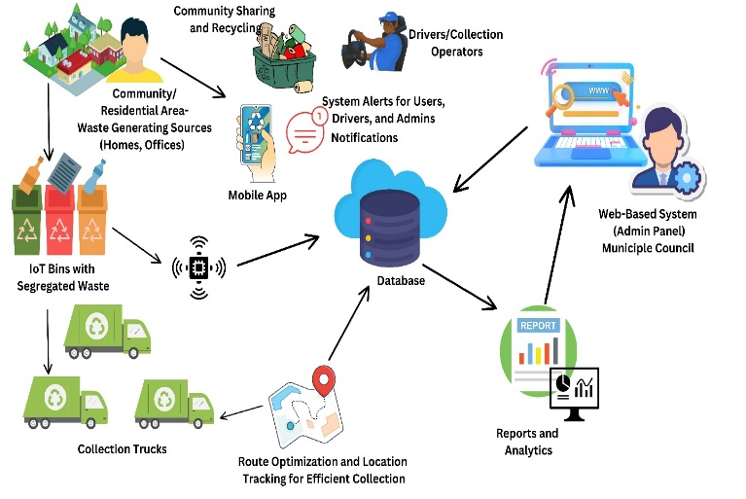
Mobile Application (for Collection Truck Drivers)
Figure 2. Architecture Diagram
Source: Author

A user-friendly and accessible app designed for truck drivers to simplify and streamline waste collection operations.Features include:
- Real-time navigation and optimized route guidance
- Dynamic route updates based on bin fill levels and user requests
- Easy access to pickup schedules and specific instructions
- Status updates for pickups (completed/pending)
- In-app notifications for new tasks or schedule changes

Smart IoT Bins
These bins are designed for residential zones and are equipped with sensors and communication modules to enable real-time monitoring (Zeb et al., 2019). Key capabilities include:
- Ultrasonic sensors to detect waste levels
- GPS for location tracking
- Wireless data transmission (LoRa/BLE) to the backend system
- LED indicators for bin status (e.g., full, error)
- Low-power consumption for long-term deployment
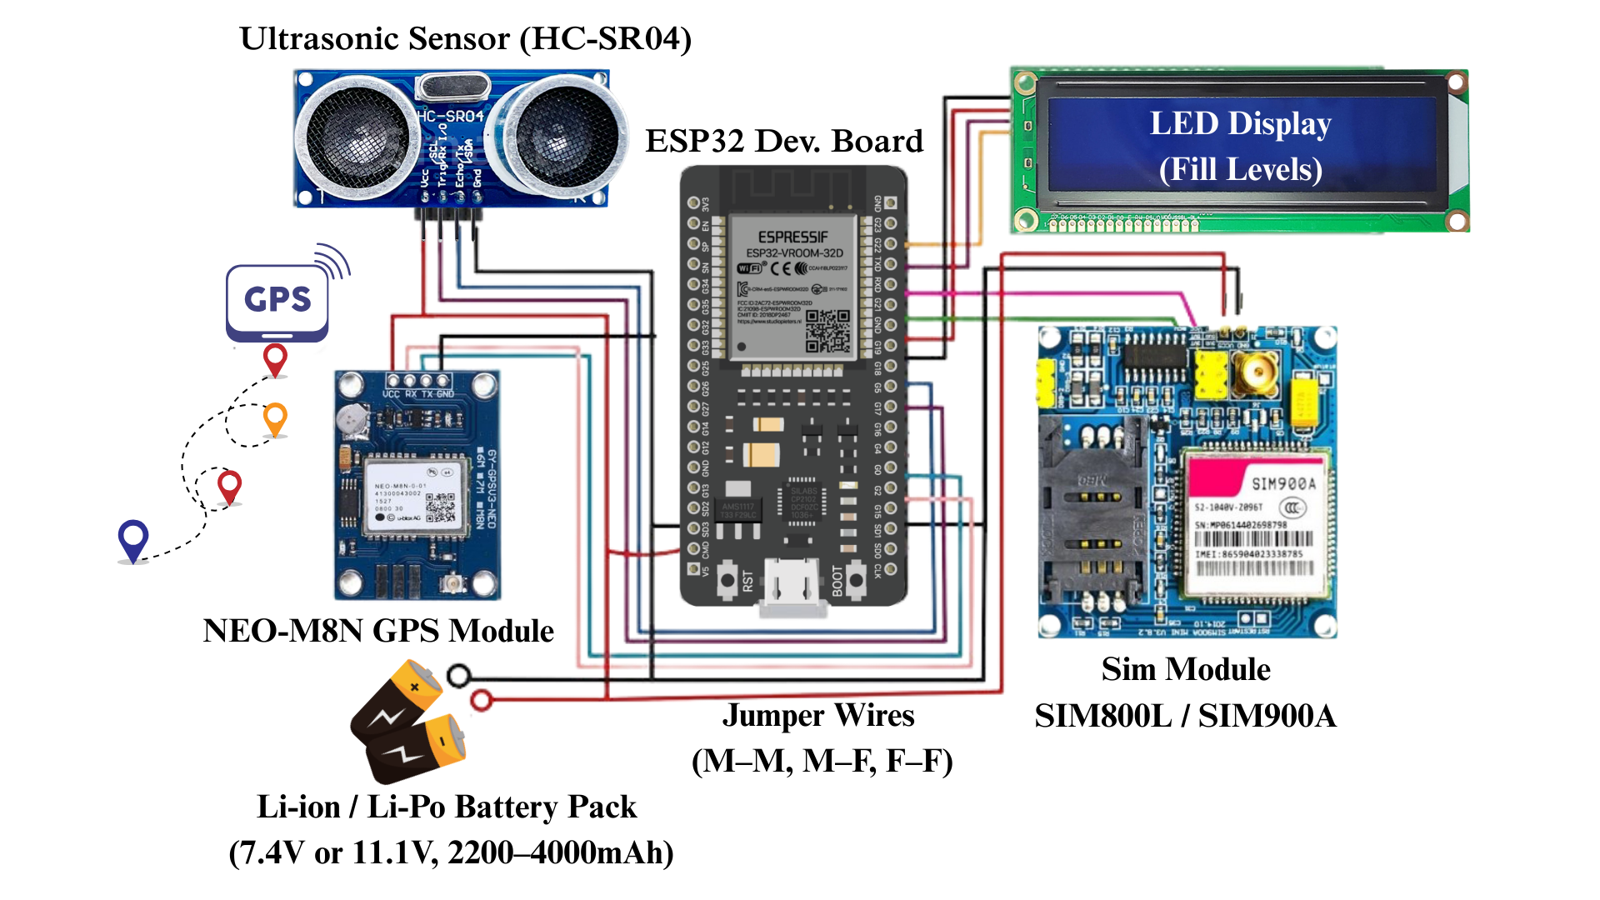
- Tamper or damage detection alerts
Figure 1. Circuit Diagram (Clea-Ro Smart Bin)
Source: Author

Figure 1, illustrates the Clea-Ro Smart Bin circuit diagram, highlighting the ESP32 microcontroller’s integration with ultrasonic sensors, GPS, and a GSM module to facilitate real-time monitoring, geolocation, and data communication.
The entire system is integrated through a firebase database that connects mobile apps, web apps, and IoT devices. Notifications and alerts are sent to users, drivers, and admins, enabling fast, data-driven responses. Figure 2, shows the architecture diagram of Clea-Ro, representing all system components and their interactions.
- Implementation
In the implementation phase, the system is being built using the technologies identified. The IoT bin is created using ESP32, with ultrasonic and weight sensors, GPS, and communication modules. These bins send real-time data to the backend via MQTT and HTTP protocols. (Fernando and Kathriarachchi, 2019)
The web-based admin panel is being developed using React, while the mobile application is built in Flutter, supporting both Android and iOS. The backend logic is handled through Node.js with Express.js, and all data is stored in Firebase, including user information, bin status, and pickup records.
System functionalities such as community sharing, multilingual support, real-time notifications, and route optimization are implemented through REST APIs and Firebase services.
- Testing
Testing evaluates sensor accuracy, interface usability, communication reliability, notifications, pickup scheduling, and multilingual community sharing. Unit, integration, and interface tests ensure each module performs as expected.
IV. Results and discussions
The development and evaluation of the Clea-Ro Smart Waste Collection System produced a range of promising outcomes, addressing longstanding inefficiencies in Sri Lanka’s urban waste collection practices. Traditionally, many municipal waste services have operated on fixed routes with limited insight into bin statuses or community needs, often leading to irregular pickups, overflowing bins, and public dissatisfaction. Through this project, those issues were studied and effectively tackled using modern technologies, real-time monitoring, and citizen participation.
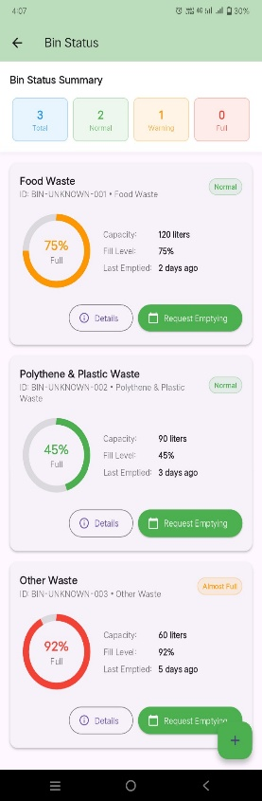
A major achievement of the system lies in its ability to overcome fixed scheduling and unresponsive operations by introducing real-time data integration through IoT-enabled smart bins. These bins are equipped with ultrasonic sensors capable of transmitting fill-level data to a centralized server. This information is visualized both in the administrator’s web dashboard and in the mobile application, enabling dynamic waste tracking. Users can monitor bin statuses from the mobile app, as shown in the Bin Status (Figure 3), and request pickups even before bins are completely filled providing them with control and flexibility.
Figure 3.
Bin Status Screen
Source: Author

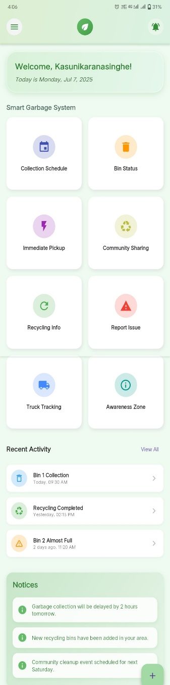
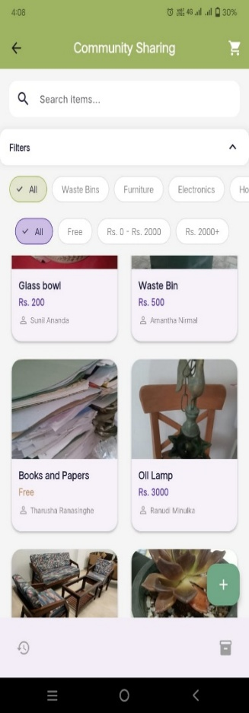
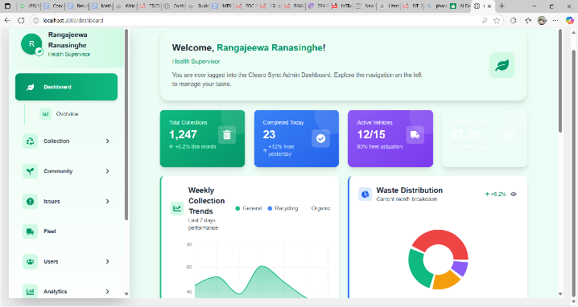
Another core outcome is the web-based admin dashboard (Figure 4), which empowers municipal councils to register bins, track truck movements, assign routes, and manage user feedback. With Google Maps integration, real-time route planning becomes more efficient, helping drivers avoid unnecessary travel. The interface displays bin data, community activity, and pickup logs, enhancing transparency and enabling data-driven decisions for waste authorities.
Figure 5. Clea-Ro App Home Screen
Source: Author

Figure 6. Community Sharing App Screen
Source: Author
Figure 4 : Admin Web Dashboard
Source: Author
Clea-Ro offers a multilingual, intuitive mobile app that simplifies waste management for residents. Users can monitor smart bins, request pickups, report issues, track collection trucks in real time, and access recycling tips all through a user-friendly interface (Figure 5). Real-time alerts on truck arrivals, missed pickups, and events promote active participation and timely waste collection. Additionally, a dedicated mobile app for collection truck drivers provides highly user-friendly and accessible tools, including real-time navigation, optimized routes, dynamic updates, and task notifications, ensuring efficient and streamlined collection operations.
A standout feature of Clea-Ro is Community Sharing, which enables users to list and browse reusable items such as furniture or electronics, reducing waste and encouraging neighborhood reuse (Figure 6). Users can chat directly with item owners, add items to a cart, checkout and leave reviews after collecting items, which helps encourage and motivate community participation. The platform also includes a Creative Works section, where users can sell products made from reusable materials, fostering creativity and providing additional benefits, rather than sharing items directly. This approach not only promotes sustainable practices but also inspires innovation and community engagement. Administrators can view and check through the web interface to monitor listings, track item exchanges, and ensure safe and efficient community participation. This oversight helps maintain system integrity, resolve issues quickly, and provide insights for improving community engagement.
The platform connects residents, drivers, and administrators through real-time updates, task coordination, and centralized data, ensuring transparency and timely responses. Powered by IoT, Firebase, Node.js, and Flutter, Clea-Ro delivers a smart, connected, and community-focused waste collection system, transforming urban waste management into a seamless, efficient, and eco-friendly experience for everyone involved.
V. Conclution
This research highlights the use of IoT, AI, GIS, and other modern technologies to improve waste collection through real-time monitoring, smart routing, and better communication. It supports reduced operational costs and environmental impact, aligning with sustainable urban goals. The system includes a community sharing feature to promote reuse and reduce waste. While challenges like setup costs and data security exist, the approach remains scalable and adaptable. Future work may enhance predictive models and deepen community involvement for improved outcomes.
references
Ablaza-Cruz, Ma.M., 2020. Designing a Mobile Application Framework as an Innovative IT Solution for Waste Recycling. IOP Conf. Ser. Mater. Sci. Eng. 803, 012046. https://doi.org/10.1088/1757-899X/803/1/012046

Alduais, N., Lim, E., 2024. An IoT and Web-Based System for Efficient Waste Collection and Monitoring. Appl. Inf. Technol. Comput. Sci. 5, 291–310. https://doi.org/10.30880/aitcs.2024.05.02.016

Arsita, T., Lapatta, N., Joefri, Y., Angreni, D., Pratama, S., 2025. Optimization of Urban Waste Collection Routes Using the Held-Karp Algorithm in a Web and Mobile-Based SystemOptimization of Urban Waste Collection Routes Using the Held-Karp Algorithm in a Web and Mobile-Based System. J. Appl. Inform. Comput. 9, 202–210. https://doi.org/10.30871/jaic.v9i1.8832

Bandara, M., Udayangi, T.G.I., 2023. Bin- Eazy: The Tracking-Based Solid Waste Collection System.

Chen, D.M.-C., Bodirsky, B.L., Krueger, T., Mishra, A., Popp, A., 2020. The world’s growing municipal solid waste: trends and impacts. Environ. Res. Lett. 15, 074021. https://doi.org/10.1088/1748-9326/ab8659

Fernando, A., Kathriarachchi, R., 2019. IoT Based Smart Solution for Waste Collection and Recycle.

Fidje, E., Haddara, M., Langseth, M., 2023. Sustainable Smart Waste Management Adoption Challenges in Developing Countries. Procedia Comput. Sci., CENTERIS – International Conference on ENTERprise Information Systems / ProjMAN – International Conference on Project MANagement / HCist – International Conference on Health and Social Care Information Systems and Technologies 2022 219, 905–914. https://doi.org/10.1016/j.procs.2023.01.366

Henrys, K., 2021. Mobile application model for solid waste collection-management. https://doi.org/10.2139/ssrn.3808542

Indrawan, K.W., Kristiawan, S., Zoe, T.M., Tania, S., Song, F.I., Saputra, J.N., Alam, I.N., Andryani, N.A.C., 2023. Digital Marketplace Design & Development for Creative Recycle Product, in: 2023 IEEE 9th Information Technology International Seminar (ITIS). Presented at the 2023 IEEE 9th Information Technology International Seminar (ITIS), pp. 1–6. https://doi.org/10.1109/ITIS59651.2023.10419958

Leelarathne, K., Niroshan, R.T., Kalansooriya, L.P., 2021. Optimum Waste Collection System with Smart Mobile Application.

Marković, D., Nikolić, L., Stankovic, A., Markovic, S., 2023. HYBRID WASTE COLLECTION SYSTEM.

Neto, A., Simões, C., Simoes, R., 2024. Optimization of municipal solid waste collection system: systematic review with bibliometric literature analysis. J. Mater. Cycles Waste Manag. 26. https://doi.org/10.1007/s10163-024-01966-y

Ogawa, A., Pandyaswargo, A., Tsubouchi, R., Onoda, H., 2023. Demonstration of a contactless waste collection system: A Japanese case study. IET Smart Cities 5, n/a-n/a. https://doi.org/10.1049/smc2.12065

Singh, D., Dikshit, A.K., Kumar, S., 2024. Smart technological options in collection and transportation of municipal solid waste in urban areas: A mini review. Waste Manag. Res. 42, 3–15. https://doi.org/10.1177/0734242X231175816

Sosunova, I., Porras, J., 2022. IoT-Enabled Smart Waste Management Systems for Smart Cities: A Systematic Review. IEEE Access 10, 73326–73363. https://doi.org/10.1109/ACCESS.2022.3188308

Wijendra, D., De Silva, D.I., Gunawardhena, N.M., Wijayarathna, S.M., Aluthwaththage, J.H., 2022. A Mobile Based Garbage Collection System, in: 2022 3rd International Informatics and Software Engineering Conference (IISEC). Presented at the 2022 3rd International Informatics and Software Engineering Conference (IISEC), pp. 1–6. https://doi.org/10.1109/IISEC56263.2022.9998268

Zeb, A., Ali, Q., Saleem, M.Q., Awan, K.M., Alowayr, A.S., Uddin, J., Iqbal, S., Bashir, F., 2019. A Proposed IoT-Enabled Smart Waste Bin Management System and Efficient Route Selection. J. Comput. Netw. Commun. 2019, 7043674. https://doi.org/10.1155/2019/7043674
Zhou, J., Jiang, P., Yang, J., Liu, X., 2021. Designing a smart incentive-based recycling system for household recyclable waste. Waste Manag. 123, 142–153. https://doi.org/10.1016/j.wasman.2021.01.030

Acknowledgment
I would like to express my sincere gratitude to all the individuals and organizations who contributed to the success of this research. I am especially thankful to my supervisor for their continuous guidance and encouragement. Special thanks to the staff of the Dehiwala - Mount Lavinia Municipal Council and all survey and interview participants for their valuable input. I also appreciate the support of my colleagues and friends for their helpful discussions and encouragement. Finally, I am deeply grateful to my family for their unwavering support and motivation throughout this journey.
author biography

I, Kebuni Ranasinghe, am a 4th year undergraduate following the BSc (Hons) in Information Technology at General Sir John Kotelawala Defence University. I am also working on my Final Year Individual Research Project on a IoT-enabled Smart Waste Collection System with Community Sharing and Real-time Route Optimization.

RPS Kathriarachchi obtained his BSc (Hons) in computer networks from the University of Wolverhampton UK and his master’s degree in MIT at the same University. Currently, he is reading for his Ph.D. at the University of Jayewardenepura. He is also a Cisco-certified network associate and has more than 18 years of IT and IS systems. His current research interests include the Internet of Things, Machine Learning, and computer networks and security. He has produced over ten peer-reviewed publications under his name.

